**Unit 2 – Worksheet 5**

**Distance vs. Displacement**

Adapted from AMTA 2006

**Part I**

An overhead view of the paths that Dorothy and Toto take along the yellow brick road is shown below.

From start to finish, who travels farther? Justify your answer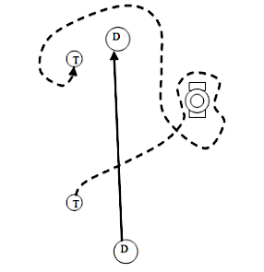.

Find a classmate with a different answer. Why did they choose this answer?

New Terms and Definitions:

More examples using the new terms:

**Part II**

**Using Number Lines to Measure Position and Finding Change in Position**

On each number line, you will see two cars: an initial car (dashed) and a final car (solid).

* Record the positions of each car.
* Write a mathematical expression for calculating the change in position of the car
* Record the change in position of the car.
* Measurements are in meters (m)

Example:

-10

0

-5

5

10

Initial Position = 0 m

Final Position = 6 m

Mathematical Expression: $x_{f}-x_{o }$ = 6 m - 0 m

Change in Position = 6 m

1.

-10

0

-5

5

10

Initial Position =

Final Position =

Mathematical Expression:

Change in Position =

2.

-10

0

-5

5

10

Initial Position =

Final Position =

Mathematical Expression:

Change in Position =3.

-10

0

-5

5

10

Initial Position =

Final Position =

Mathematical Expression:

Change in Position =

-10

0

-5

5

10

4.

Initial Position =

Final Position =

Mathematical Expression:

Change in Position =

-10

0

-5

5

10

5.

Initial Position =

Final Position =

Mathematical Expression:

Change in Position =

-10

0

-5

5

10

6.

Initial Position =

Final Position =

Mathematical Expression:

Change in Position =